**PERSONAL STATEMENT**

_________________________________________________

**MY EXPERTISE**

_________________________________________________

**EDUCATION**

_________________________________________________

I'm an experienced **Mobile First Front-End Web Developer** based in Atlanta, GA. My work is always of the highest quality; I take on each project as though it were my own. My expertise includes, but is not limited to, HTML5, CSS3, jQuery/JavaScript, JSON, Angular.js, other JS libraries, Agile Development, Wordpress, SQL, and PHP.

I’m punctual, creative, and responsible. I work well with management, peers, and clients from all backgrounds. I’m looking to move into a permanent leadership role with room for advancement.

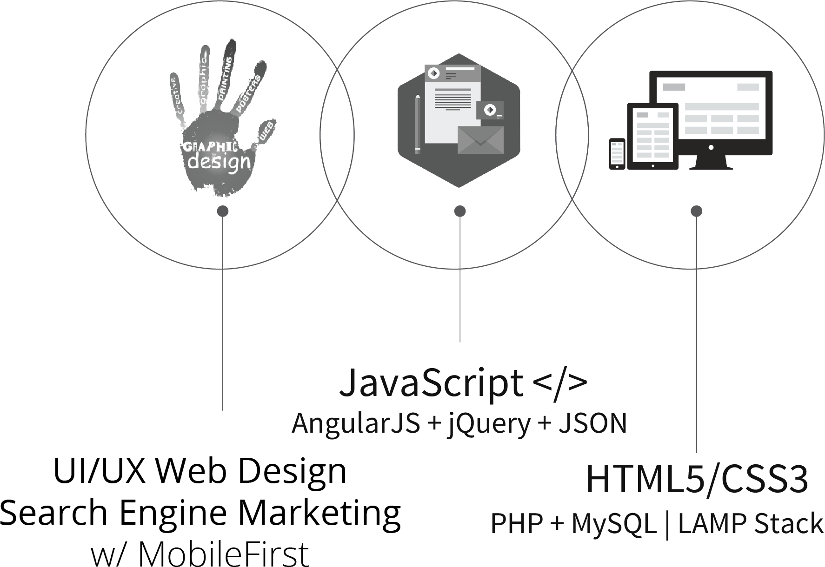

**BACHELOR OF ARTS IN BUSINESS ADMINISTRATION**

CLARK ATLANTA UNIVERSITY

**W3 CERTIFICATIONS**

HTML5, CSS3, jQuery, Javascript, PHP

**REFERENCES**

_________________________________________________

**RECOGNITIONS**

_________________________________________________

SQL Programmer of the Year (2013) LeasePlan USA Internal contest. One of the three finalists. Alpharetta, GA $1,300 Payroll bonus

**Amanda Miller** for TroposFitness

*www.troposfitness.com*

**amanda.marie.miller3@gmail.com**

**Marie Nealis** for Stanely Nursery School

*www.stanleynurseryschool.com*

**mnealis1@optonline.net**

**CAREER EXPERIENCE**

_________________________________________________

**Luma Home WiFi** From September 2016 to Present

**Mobile First, UI/UX Front-End Web Developer (eCommerce)**

* Develop new user-facing features with reusable code and JS libraries
* Ensure the technical feasibility of UI/UX designs
* Optimize web applications for maximum speed and scalability by using frameworks and libraries such as AngularJS.

**Georgia Federal Credit Union Affiliates (GFCUA)** From April 2016 to Feb. 2017

**Sr. Front-End Web Developer**

* Design and Develop websites and marketing material for GA credit unions
* Work as the sole Content Management System (CMS) developer for all clients
* Provide scripting support for complex websites requiring advanced JavaScript, PHP, etc.

**LeasePlan U.S.A.** From February 2012 to July 2014

**Procurement Dept. Analyst (2012) ; SQL Programmer for S.M.A.R.T. (2013-2014)**

* Designed all graphic presentation material for the Procurement Department
* Defined department objectives by analyzing both user and client requirements
* Designed database tables and construct SQL queries for data extraction

**Comcast** From March 2011 to February 2012

**Business Support Analyst**

* Wrote SQL queries to extract B2B data
* Assist back-end developers with coding and troubleshooting

**AT&T** From November 2004 to December 2010

**Retention Analyst**

* Designed reporting tools that improved efficiency by 30%, reduced expenses and labor costs by 17%, and maximized profit by automating out-dated manual processes
* Responsible for developing tools/marketing promos that were used by the customer service group to successfully retain customers.